**Jemma Johnston**

**Cohort E20**

**PDA: Analysis & Design**

**AD:1 Use Case diagram**

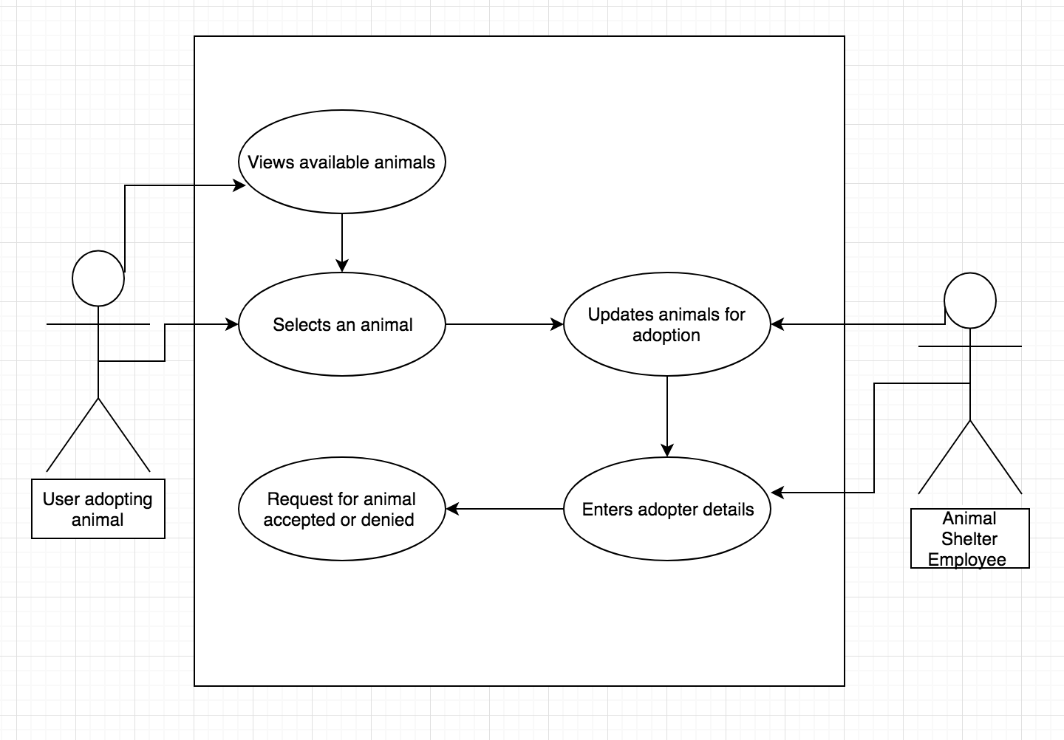

**AD:2 Class Diagram**

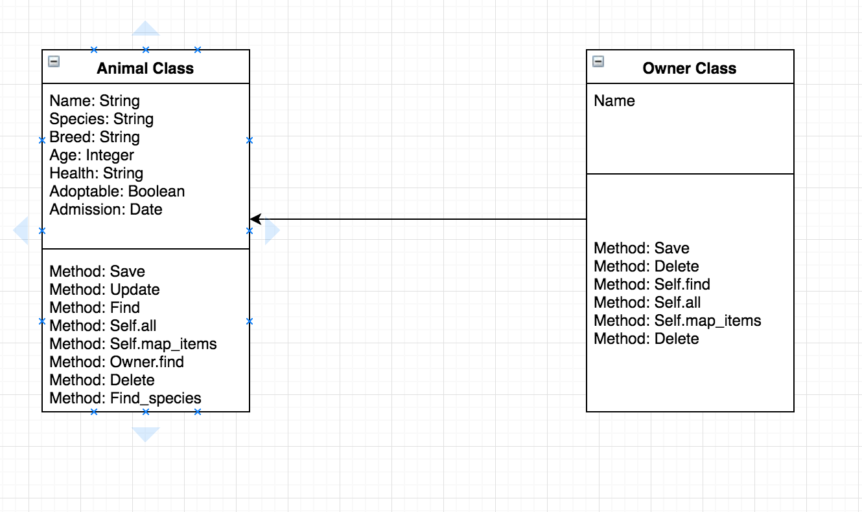

**AD:3 Object Diagram: One to Many**

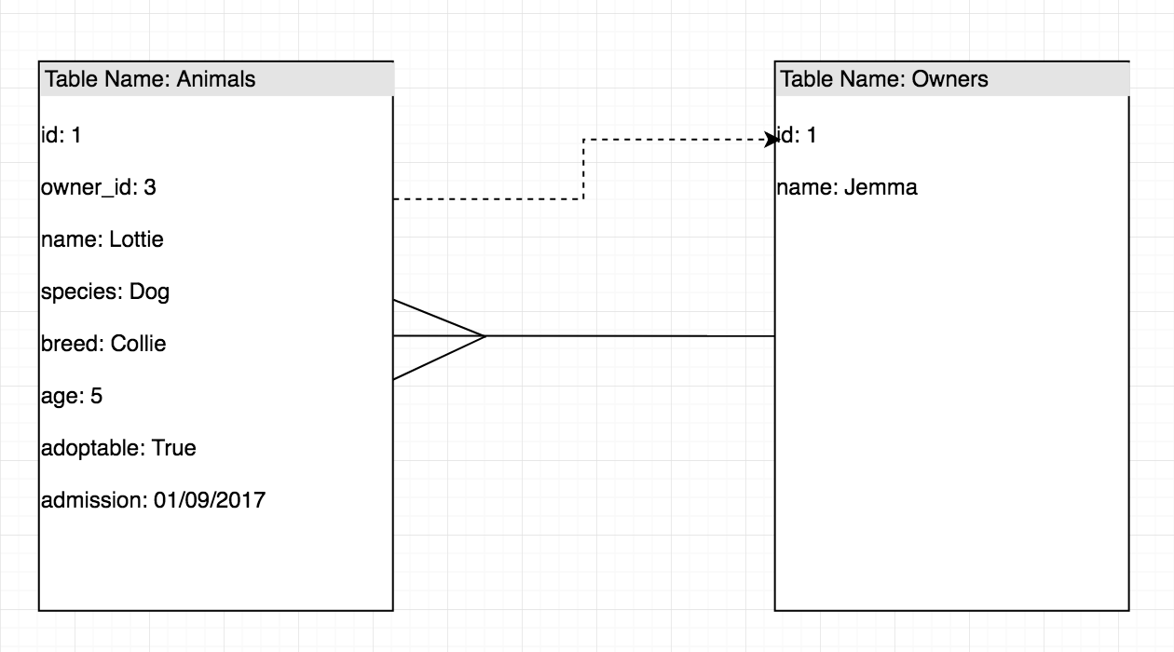

**AD:4 Activity diagram**

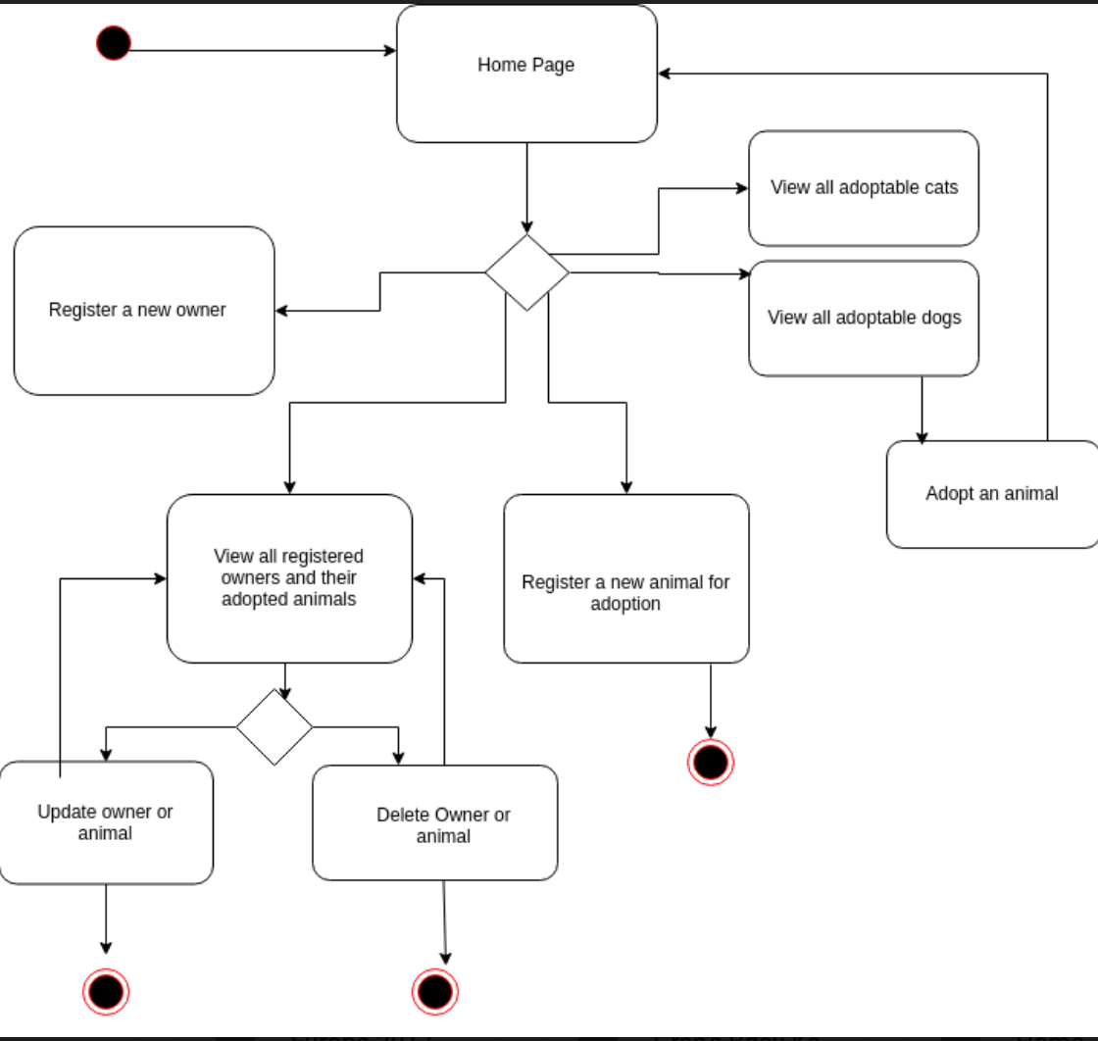

**AD:5** **An Inheritance Diagram:**

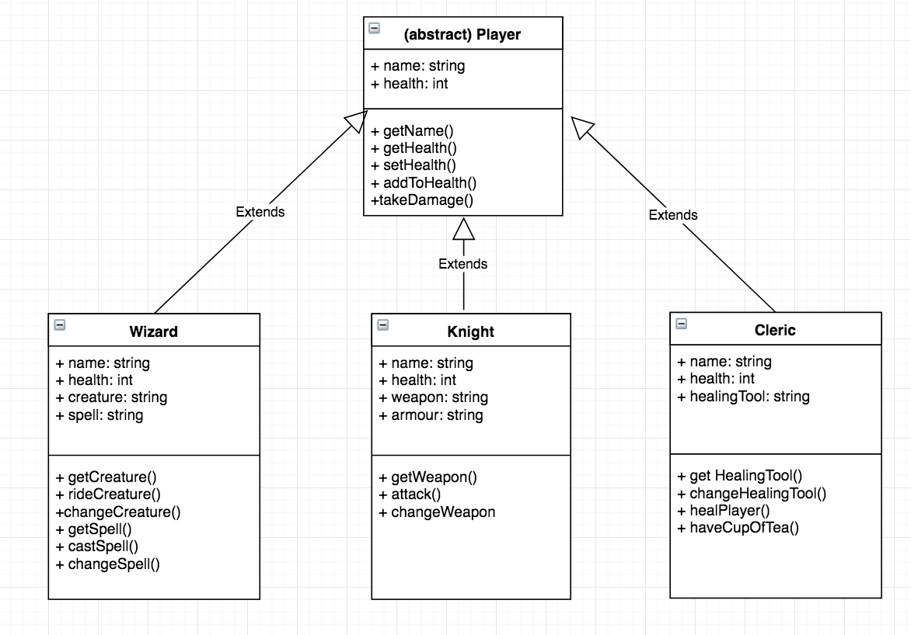

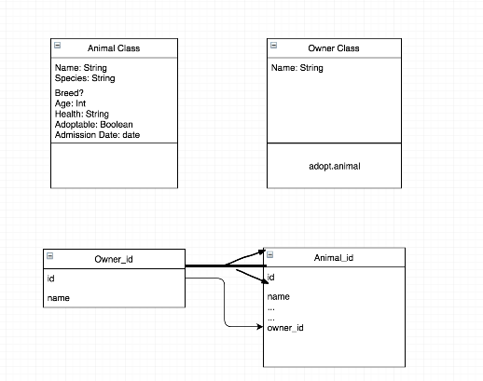

**AD6: Implementation Constraints Plan**

